Make sure to download the DESIGN TRENDS 2020 zip file which contains a few of the downloadable resources talked about in the lessons. These are the links to external helpful resources. **The student projects are outlined in detail below on page 2!**

**Trends in Typography**   
Variable Fonts  
  
Getting started with Variable fonts  
<https://speckyboy.com/variable-fonts/>

Test them out in the Font Playground

<https://play.typedetail.com>

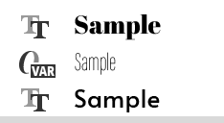  
Another variable font to download

<http://koe.berlin/variablefont/>

**HOW TO USE VARIABLE FONTS *Requires photoshop version 2018 or newer to load variable fonts*** *Adobe Photoshop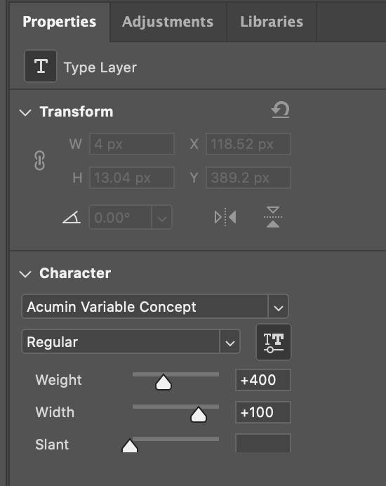   
  
1.) Download and install a variable font just like you would any other font. In your font list you will now notice this VAR symbol next to the font.*

2.) Go over to your properties panel to be able to have extra adjustments not available on other standard fonts.

**Hand Drawn Assets**   
Wedding Photo - <https://www.pexels.com/photo/woman-sitting-on-red-lounger-2846544/>

Magazine Mockup - https://graphicburger.com/?s=magazine

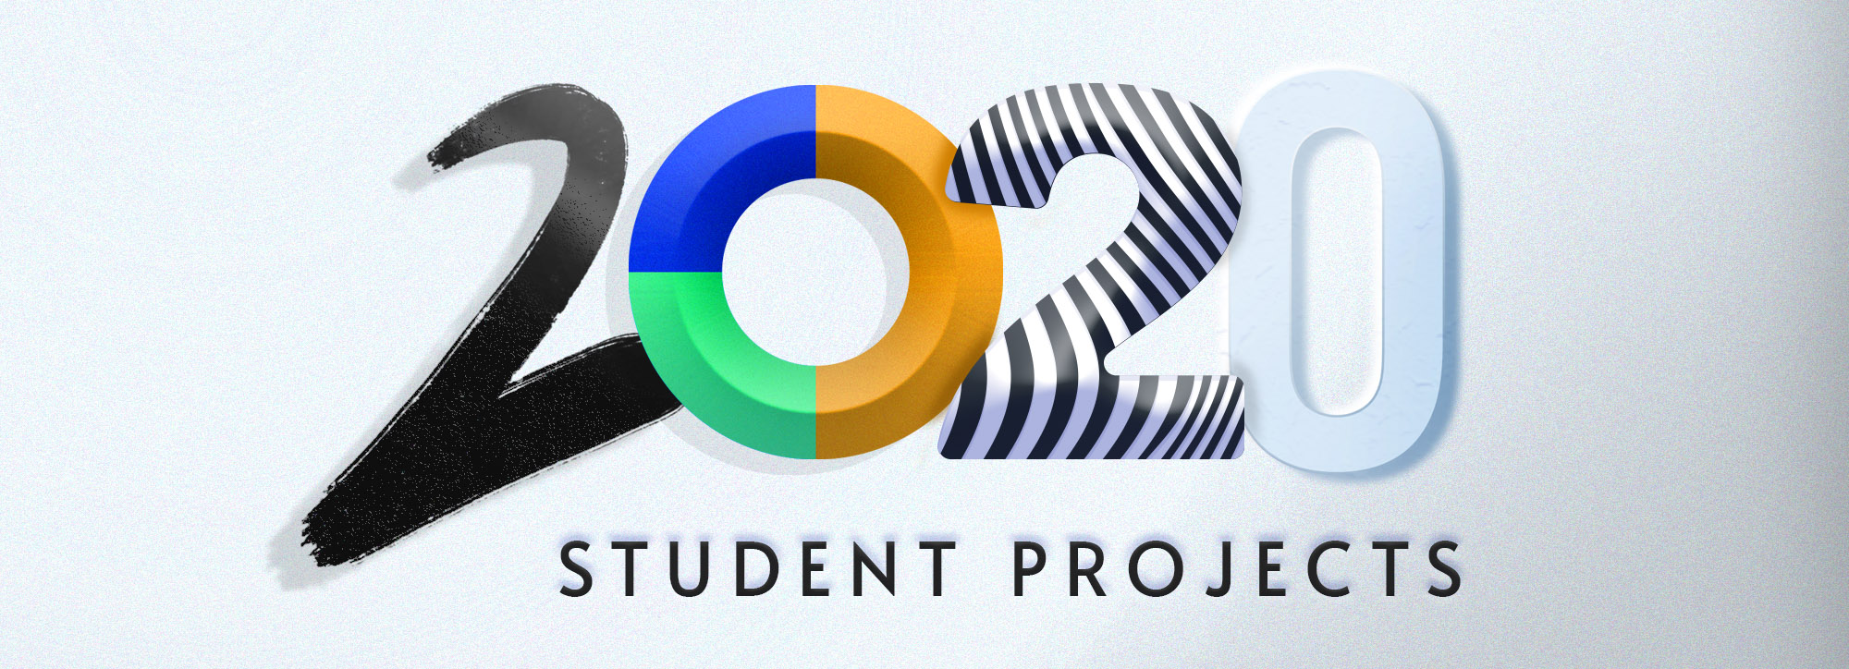

**Make sure to download the zip file to the left of the project section of the course to have access to some of the course files and links.**

You have been tasked in each lesson with a unique project! Feel free to **pick one of your choice** to post in the project section (Q&A) of this class (although if you post multiple that is wonderful too!). You can also post it in the student [Facebook group.](https://www.facebook.com/groups/LindsayMarshTeachesDesign/)

**1.) A Distorted Typography Poster**

Your task is to create a poster using distorted or warped text using the envelope distort tool in Adobe Illustrator. You can do a simple word or a repeated word block of type.

**2.) Create a Skeuomorphism Style Button or UI Element**

Feel free to do this in your program of choice. Create a realistic UI element or button using the methods we reviewed in the lesson. Feel free to use highlights and shadows to create buttons, knobs, dials and more.

**3.) Create and Use Hand-drawn Assets**

Use a digital sketching app, or a Wacom tablet, or you can even use traditional methods like watercolor or pen and paper to create a few hand-drawn graphics. As a bonus, you can use those hand-drawn assets in a design piece of any kind.

**4.) Create a frame animation GIF in Photoshop**  
Create at least a 2-8 frame animated GIF using the Photoshop timeline feature. It can be a social media graphic or a GIF to show off your work.

**5.) Create an Abstract Geometric Poster**  
Using only circles, create a geometric design poster by cutting out shapes and arranging them using the Grid system.